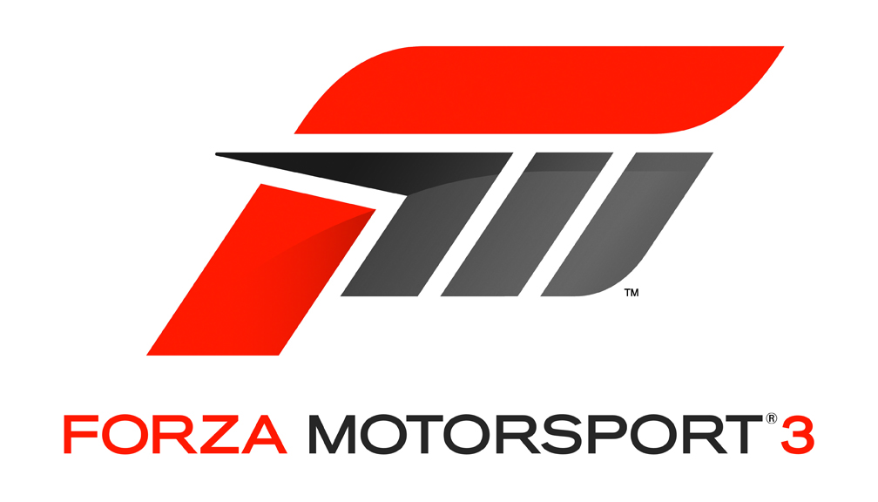

Fact Sheet

June 2009

Title: “Forza Motorsport 3”

Availability: October 2009
Publisher: Microsoft Game Studios
Developer: Turn 10 Studios
Format: DVD for the Xbox 360 video game and entertainment system; Xbox LIVE-enabled
ESRB Rating: E for Everyone
Pricing: $59.99 U.S. (ERP)
$79.99 U.S. for Limited Collector’s Edition

Product
Overview: Whether it’s an exotic sports car like the new Audi R8 V10, a classic American muscle car like the Ford GT or a hot Asian import like the Nissan 370Z, everyone has a dream car. Now you can drive that dream with Turn 10’s latest racing epic. Launching this October exclusively for Xbox 360, “Forza Motorsport 3” unites the racing game genre, making it possible for everyone to experience the thrill of the world’s most exotic and exquisite cars. Live the most realistic racing experience ever as you take the wheel of more than 400 of the most-beloved cars on over 100 renowned real-world tracks and exotic road courses from around the globe. With breathtaking high-definition graphics and the most advanced vehicle performance modeling in a video game, “Forza Motorsport 3” includes a host of driving assists and adjustable skill levels to make the game a gripping pick-up-and-play experience for audiences of all ages and skill levels.

Your escape into the world of car culture in “Forza Motorsport 3” doesn’t stop at the track. Turn 10 is a proven leader in user-generated content creation in games. “Forza Motorsport 3” further fuels the imaginations of its already thriving community of painters, tuners and photographers with improved customization tools and brand-new ways to share creations with the world via Xbox LIVE.* Xbox LIVE makes your journey into the “Forza Motorsport” community and the world of user-generated content easy and fun.

A love of cars lives in all of us. “Forza Motorsport 3” is the automotive playground we’ve all been waiting for.

Features: Top features include the following:

- Where dreams are driven: The cars and tracks. Featuring the latest and greatest production offerings as well as the world’s fastest and most exotic street cars, “Forza Motorsport 3” offers more than 400 fully customizable and tunable cars from over 50 of the world’s leading manufacturers. Whether your passion is classic American muscle cars, European roadsters, purpose-built race cars or high-tech Asian imports, “Forza Motorsport 3” puts you in the cockpit of the cars you love.
In addition to the return of world-famous tracks from previous “Forza Motorsport” games, including Suzuka, Nürburgring Nordschleife and the Sebring International Raceway, “Forza Motorsport 3” invites you to conquer the corners on more than 100 tracks, including some of the most beautiful road courses in the world. New environments like the gorgeous mountainous Montserrat region in Spain, the rugged Amalfi Coast in Italy and the American Southwest are presented in such majestic detail that you might find yourself pulling over just to take it all in.
- The look and feel of a modern racing game: “Forza Motorsport 3” is the definitive racing game. The appreciation of the automobile in “Forza Motorsport 3” is due in large part to the team’s attention to detail. This is why automotive engineers from manufacturers like Audi and champion race teams like Peugeot as well as experienced computer graphics specialists from across Microsoft Corp. have all teamed up with Turn 10 to make “Forza Motorsport 3” the most beautiful and realistic racing game ever made. All 400-plus cars in the game have been built with more than 10 times the amount of polygons as “Forza Motorsport 2.” This includes painstakingly researched cockpits and interiors for every vehicle. But realism isn’t just about pretty graphics. Turn 10 takes realism to new heights, leading the industry with the most advanced physics model, artificial intelligence and damage calculations. Whether it’s the differences in how each car handles through the corners, how the engines sound at top speed or how different tires and upgrades impact your car’s performance, you’ll find yourself leaning into your turns as if you were really behind the wheel of your favorite ride.
- It’s easy to go for a spin: “Forza Motorsport 3” redefines the racing genre. Simulation games can be too hard for some players. “Forza Motorsport 3” rises above the distinction between simulation and arcade games. Using a myriad of cutting-edge driving and gameplay assists such as auto-braking, gameplay rewind and auto-tuning, “Forza Motorsport 3” delivers an experience where everyone can have fun behind the wheel, regardless of your skill and dexterity. Whether you’re a newcomer or a seasoned racing game pro, “Forza Motorsport 3” caters to how you drive and evolves with you over time as your skills increase.
- Express your car passion: User-generated content and Xbox LIVE. Painters and tuners will once again be able to showcase creativity through the celebrated Livery Editor, Auction House and deep tuning garage in “Forza Motorsport 3.” The car is literally the artistic canvas as some of the world’s most creative car painters and designers find new layers of depth and freedom to create shocking visual masterpieces before sharing them with others over Xbox LIVE.* Each car in “Forza Motorsport 3” is fully upgradable, allowing gear heads to take on the challenge of turning a Honda Civic into a supercar killer. New Xbox LIVE Leaderboards celebrate not only the greatest racers but also the most prolific car tuners and painters in the community.
- Play your way: New game modes. “Forza Motorsport 3” is an epic racing game featuring more content and more ways to play than any racing title today. An innovative single-player season mode puts you through a completely personalized racing calendar that includes more than 200 different events, including Circuit, Oval, Drag, Drift and Timed Events. No two calendars are the same; they react to the cars you love and the races you enjoy most. In addition, the online multiplayer mode* gains an all-new game rules editor. This gives players a never-ending variety of ways to play with friends. Whether you’re a speedster, dragster, drifter, painter, tuner or just a lover of cars, “Forza Motorsport 3” is the definitive racing game for you.

About Turn 10
“Forza Motorsport 3” is piloted by Turn 10 Studios of Microsoft Game Studios. The experienced development team, led by franchise director Dan Greenawalt, is composed of top developers, real race drivers and car collectors whose pedigrees include work on top racing franchises such as “Forza Motorsport,” “Project Gotham Racing” and “RalliSport Challenge.” In 2007, Turn 10 released its most recent title, “Forza Motorsport 2,” garnering racing game of the year awards from IGN Entertainment Inc., Yahoo! Inc., GameSpot, and the Academy of Interactive Arts & Sciences. More information is available at http://www.forzamotorsport.net.

The information contained in this fact sheet relates to a pre-release product that may be substantially modified before its first commercial release. Accordingly, the information may not accurately describe or reflect the product when it is first commercially released. This fact sheet is provided for informational purposes only, and Microsoft makes no warranties, express or implied, with respect to the fact sheet or the information contained in it.

* Xbox LIVE Gold account required for online multiplayer gameplay.

For more information, press only:
Joe DiMiero, Edelman, (323) 202-1063, joe.dimiero@edelman.com
Kristine Steimer, Edelman, (323) 202-1075, kristine.steimer@edelman.com

